1/7/2015 K S R T C.



|  |  |
| --- | --- |
| *E­Ticket/Reservation Voucher* | |
| PNR Number : J47739594 | Date of Journey : 11/01/2015 |
| Trip Code : 1330BNGCBT | Class of Service : AIRAVAT |
| Seat No(s) : 13 | Service Start Place : BENGALURU |
| Passenger Start Place : MYSURU | Service End Place : COIMBATORE |
| Boarding Point : MYSURU BUS STAND | Booking Counter : ONLINE |
| Departure Time : 16:45 Hrs. |  |
| Platform Number : 3 |  |
| Passenger End Place : COIMBATORE |  |
| Alighting Point : MTP ROAD BS |  |
| COIMBATORE |  |
| No. of Seats : 1 (Adults=1 ; Children=0) |  |

|  |  |  |  |
| --- | --- | --- | --- |
| Passenger Information |  |  |  |
| Name | Age | Adult/Child | Gender |
| 1 Yashwanth | 26 | Adult | Male |

Total Fare Details in Rs.

Total Fare: 328.00 (incl. of Reservation Fee Rs. 10.00, Payment Gateway Charges Rs. 8.00 )

Enroute Refreshment Stops: Important

The seat(s) booked under this ticket is/are not transferable.

This e­ticket is valid only for the seat number and bus service specified herein.



This e­ticket has to be carried by the passenger during the journey along with any one of the following ID cards; Driving License(Original/Photo copy), Voter ID Card (Original/Photo copy), PAN Card(Original/Photo copy), Passport(Original/Photocopy),Ration Card (with passenger photo) (Original/Photo copy), Senior citizen ID card (issued by KSRTC/Govt) (Original/Photo copy), ID card(with Photo) issued by Govt Depts (Original/Photo copy), Private company ID card (original), Educational Institution ID card (original).



Ticket will become INVALID, if ID proof is not produced and passengers will be treated as 'Travelling without ticket'.

Please keep the ticket safely till the end of the journey.



Please show the ticket and ID proof at the time of checking.



Passenger travelling with Senior Citizen concession need to produce any one of the following ID proof in original at the time of journey ­ Senior citizen identity card issued by KSRTC, Identity card issued by the Physically Challenged and Senior Citizens Welfare Directorate, Driving Licence,



http://www.ksrtc.in/AWATAROnline/manageEbk.do?PrintType=Onward 1/2

1/7/2015 K S R T C.

Voter ID and Passport, issued by the concerned authority of State of Karnataka.

Free Travel is permitted in City Buses (except A/C buses) within the City limits before 2 Hours of the departure time on production of eticket print­outs only. Free travel based on Mtickets is not allowed.



All departure / arrival timings are in 24 hour format i.e 8:00 AM will be displayed as 08:00 hrs and 8:00 PM as 20:00 hrs.

If booked ticket does not meet passenger requirements, user needs to cancel the ticket and rebook with correct details.



Refunds for cancellation of online tickets will be made to customer?s bank account only. Cash refunds are not allowed.



Cancellation of online tickets by the user is confirmed through email and SMS.



Corporation reserves the rights to change/cancel the class of service.



For detailed terms and conditions, refer 'Reservation Terms' on KSRTC website (www.ksrtc.in).



Important: All users are requested 'Not to share their online banking / Credit card / Debit card details to any person from any organization'.

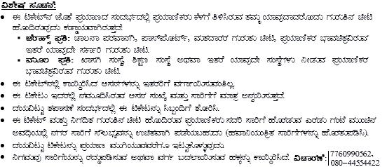

Booked By: Yashwanth(yashu_150@yahoo.co.in) Printed On: 07/01/2015 At: 13:23:06



http://www.ksrtc.in/AWATAROnline/manageEbk.do?PrintType=Onward 2/2